Ohio Test “A Pilgrim on the Silk Road” Name ____________________________

Question 1

A B C D

Question 2

A B C D

Question 3

A B C D

Question 4

A B C D

Question 5 Pick 2

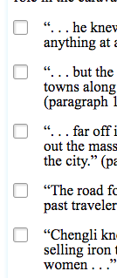

Question 6

A B C D

Question 7 Pick 3
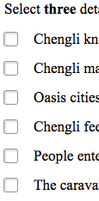
Question 8

A B C D

Question 9
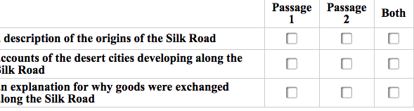
"Video Games and Physical Health"

Question 10
Part A: A B C D

Part B: A B C D

Question 11

Part A: A B C D

Question 11 Part B

Detail one __________________________________________

Detail two __________________________________________

Question 12

A B C D

Question 13
Part A: A B C D

Part B: (Pick 2) A B C D E

Question 14
A B C D

Question 15
Part A: (2) A B C D E

Part B: A B C D

Question 16
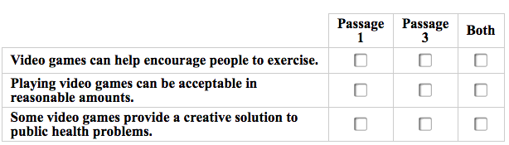
Question 17
